Play Ball!
Sign-ups for early spring baseball camps will be on February 26 and 27 at the Green Diamond Center.
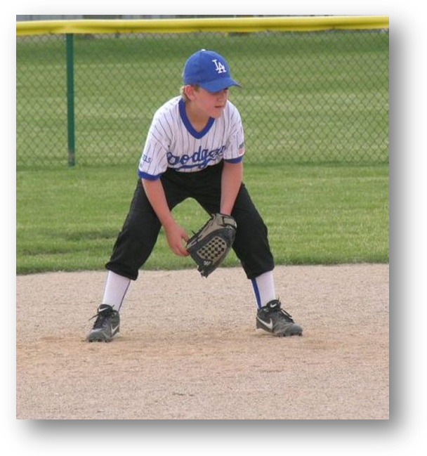
- Indoor facility with batting cages
- Speed and conditioning training
- Pitching, hitting, and fielding practice

Call Mike at 555-2241 for more information.

