Learn to Ride
High-quality Western and English riding lessons, focusing on safety and including instruction on horse care, saddling a horse, and other aspects of horsemanship.
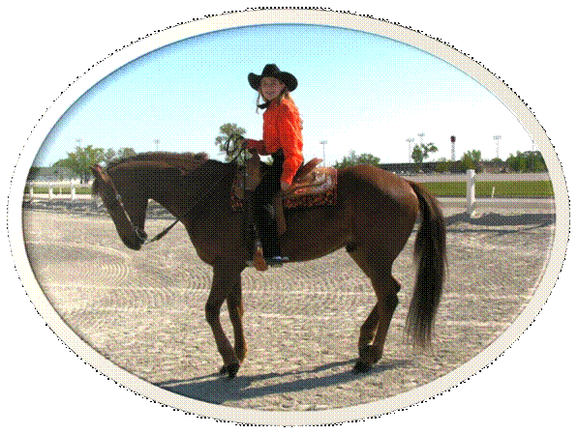

- Novice to advanced instruction for children and adults
- Indoor and outdoor arenas
- $40 per hour for private lessons; $25 for group lessons

Call Tri-Valley Stables at 555-2030 today!

