Autumn Festival
The 25th Annual Honey Creek Autumn Festival will be held the weekend of October 4 and 5 at Honey Creek Farm.
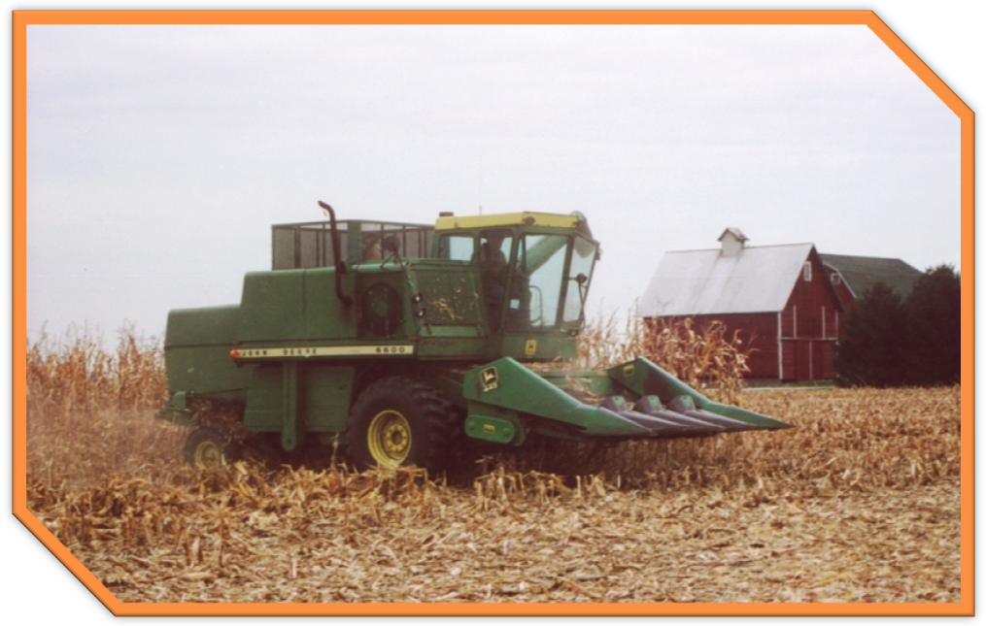
- Quilting and canning demonstrations
- Music and dancing
- Craft items and produce for sale

Don’t Miss This Year’s Fest!

